Cloud Formation Stack for S3 Bucket creation

Open a CloudFormation console from AWS

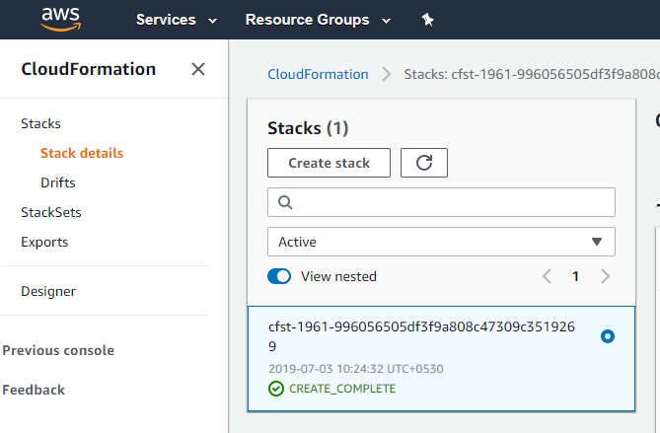

Then we have to create stack

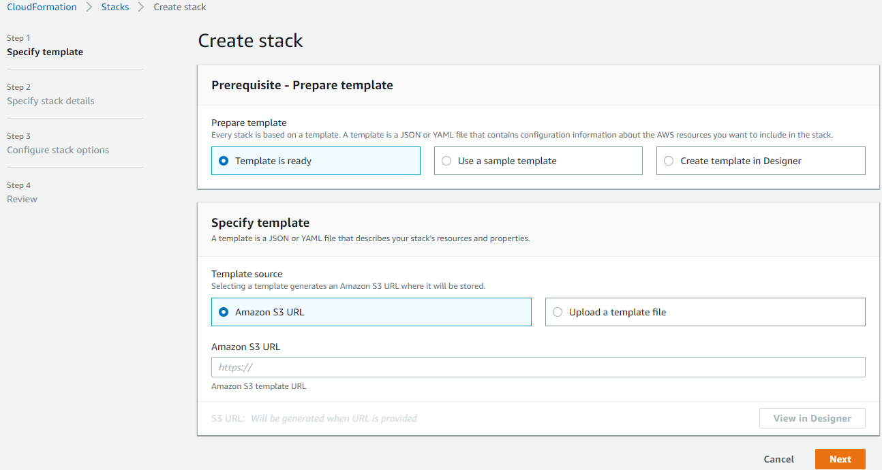

Here I going to upload a template below JSON code file which I already created in JSON format.

{

"Resources" : {

"nissan" : {

"Type" : "AWS::S3::Bucket"

}

}

}

JSON file has been uploaded below.

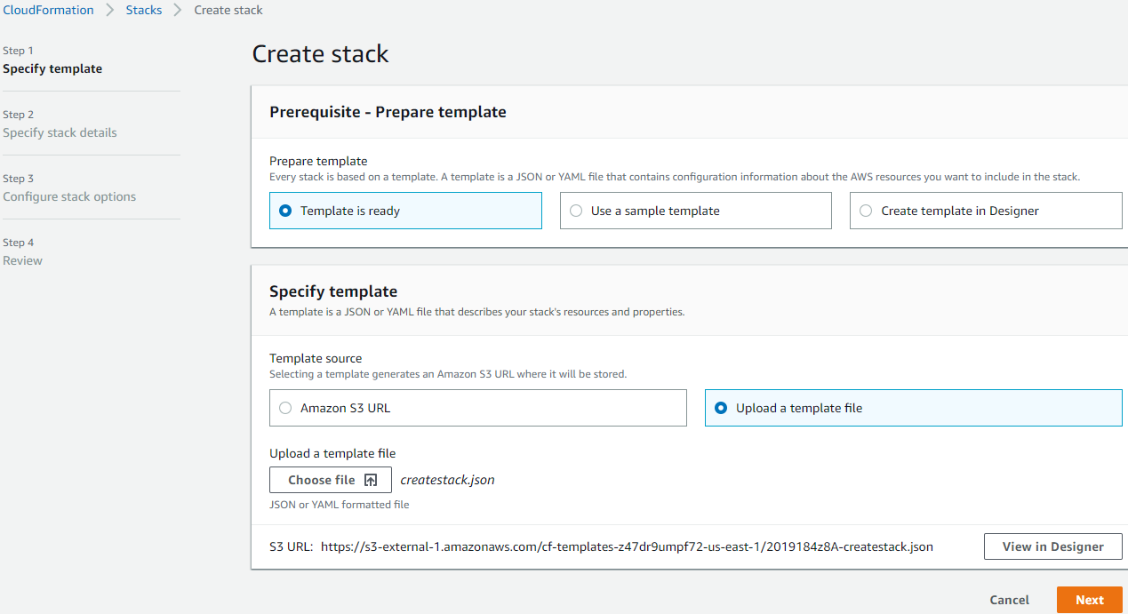

Next , we have to give stack name

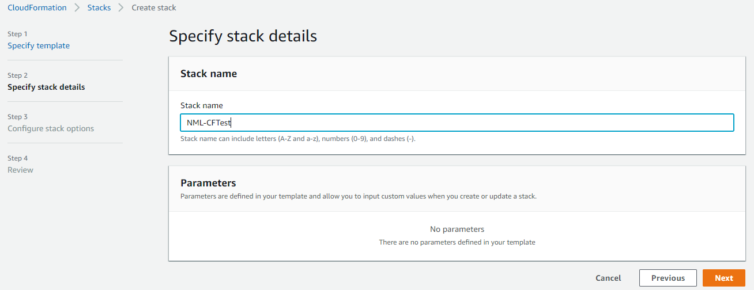

Once we reviewed below , stack will be created.

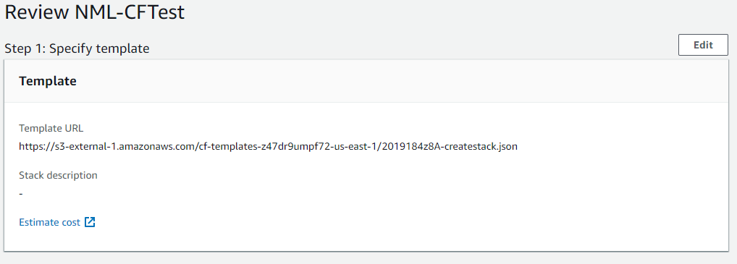

Stack created as NML-CFTest

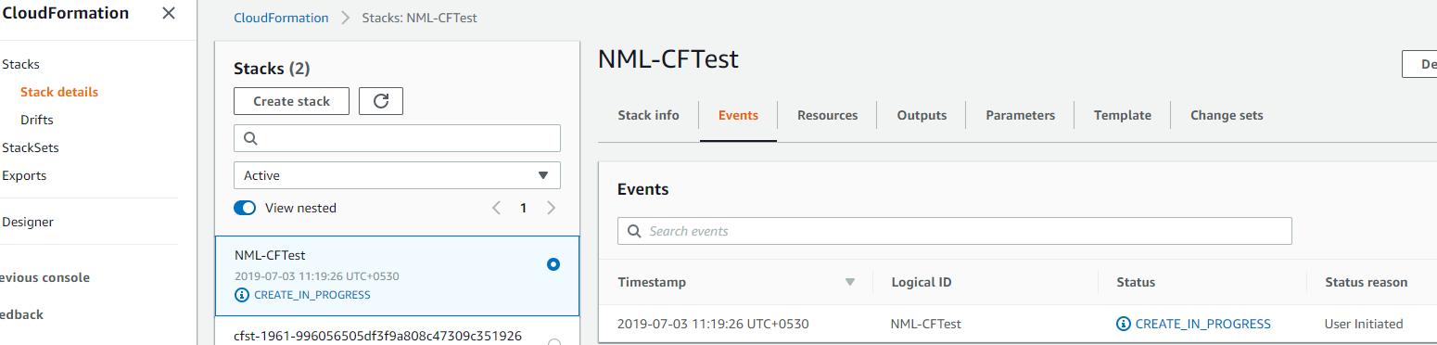

Event logs generated from console

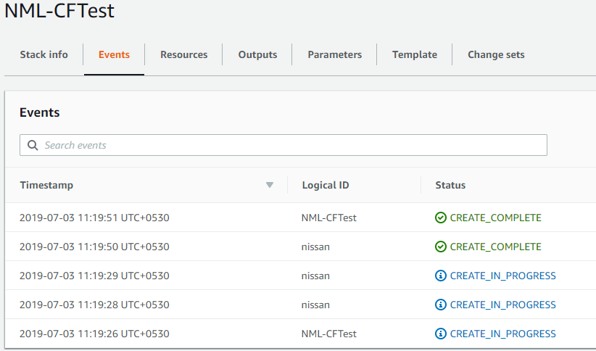

Finally we can check on s3 console, nml-cftest-nissan s3 bucket has created via JSON file.

